1. From the given figure alongside, answer the following questions. [3]
(a) Name the arms and vertex of given angle.
(b) Measure the given angle by using protractor.
(c) Name the type of angle on the basis
D
C
B
A
O
N
M
of its measurement.
2. Look at the figure and answer the following questions.
(a) Name the quadrilateral and its sides. [1]
(b) Write the measurement of ∠A and ∠B and
find the sum of ∠A and ∠B. [2]
(c) Find the value of Z. [2]
3. The population of Germany in January 2023 is eight crore forty-four lakh seventy-eight thousand four hundred eighty one.
(a) Rewrite the population in numerals. [1]
(b) Write the place value of 7. [1]
(c) Round off 765 to the nearest hundred. [1]
(d) Represent the above number in place value table of national system. [2]
4. Convert the followings into seconds.
(a) 15 minutes 40 seconds. [1]
(b) Hari can do a piece of work in 40 minutes. In how many hours and minutes can he do such 5 pieces of work? [2]
(c) How many days are there in a leap year? [1]
5. Find the result.
(a) 198.52 m – 13.75 m [1]
(b) Find the sum of: 14:32, 15:36, 18:42. [2]
(c) A man has Rs. 500.50 daily income. If he spends Rs. 200.75 from this then what is his daily saving? [2]
6. Do the following activities.
(a) Multiply. [2]
km m cm
12 3 8
× 12
(b) A 20 m 64 cm long ribbon is to be divided into 4 equal parts. Find the length of each part. [2]
7. (a) How many Litre are there in 1 ml? [1] (b) Do you use measuring pot or measuring tape to measure the oil used in your kitchen? [1]
(c) Multiply. [2]
l ml
50 600
× 8
8. Do the following activities.
(a) What is the formula to find perimeter of square. [1]
(b) Find the perimeter. [1]

5cm

(c) Find the perimeter of a rectangular ground whose length is 40 m and breadth is 30 m. [2]
9. A rectangular garden is shown below.

30 M

40 M
(a) Find the area of garden. [2]
(b) If length of the garden is increased by 10 m and width is reduced by 10 m, what effect would be in area? [2]

10.
Readmore Books Distributors
Tandi, Chitwan

Date : 2082-01-14
Address : Tandi

Bill No.450
Customer's name: Anjana Wagle

S.n | Description | Quantity | Rate(Rs) | Amount(Rs)
1 | Pen | 6 | 25.00 | 150.00
2 | Notebook | 5 | 50.00 | 250.00
3 | Ink | 2 | 40.00 | 80.00

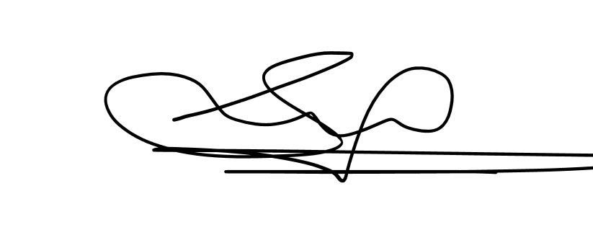

Sign
In words: Four hundred and eight only.
Total : 480

(a) What is the name of customer?. [1]
(b) What is the total cost of 5 Notebook. [1]
11.Humans have 32 teeths, Dolphins have 200 teeth, Dog have 42 teeths, cows have 32 teeths. Tabulate this information. [. [3]
12.Find the Following
(a)solve: x−5=7 [1]
(b) Write the coefficient and variable in the given expressions:
19 Z [1]
(c) If 2x+5=13 find the value of x. [1]
(d) Write the Given Phrases as an Algebric Expressions : [2]
4 times of x and three times of Y are added.

-------------THE END----------------

